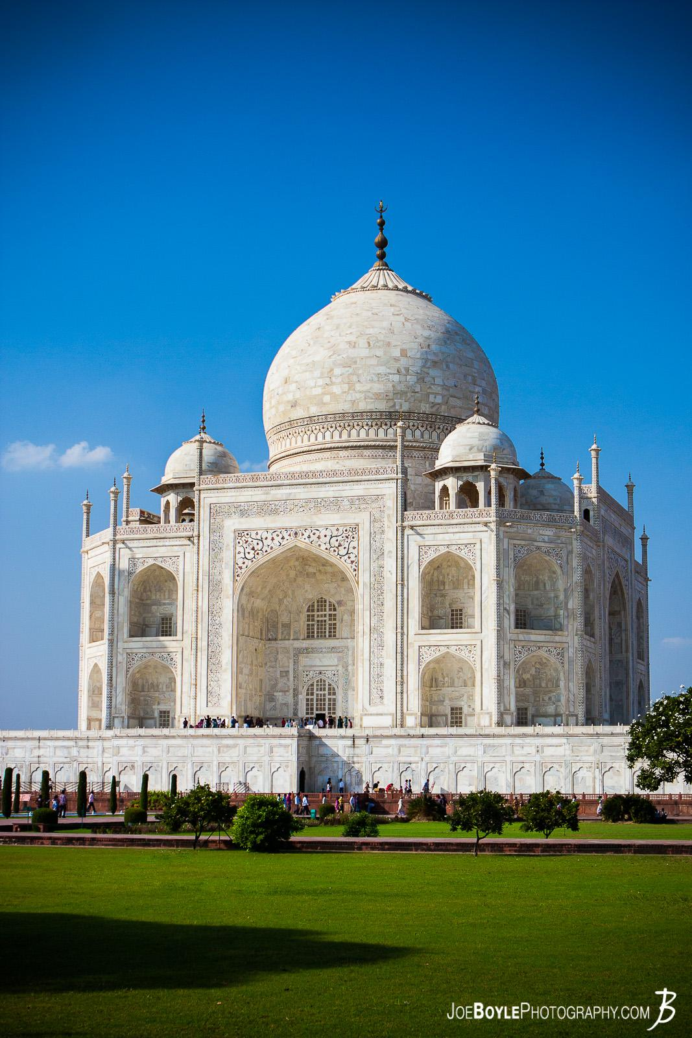

Taj Mahal

4.6

(2.3L)

Monument

The Taj Mahal is an ivory-white marble mausoleum on the right bank of the river Yamuna in Agra, Uttar Pradesh, India. It was by the fifth Mughal emperor.

**Ticket Fees : Rs.1,000**

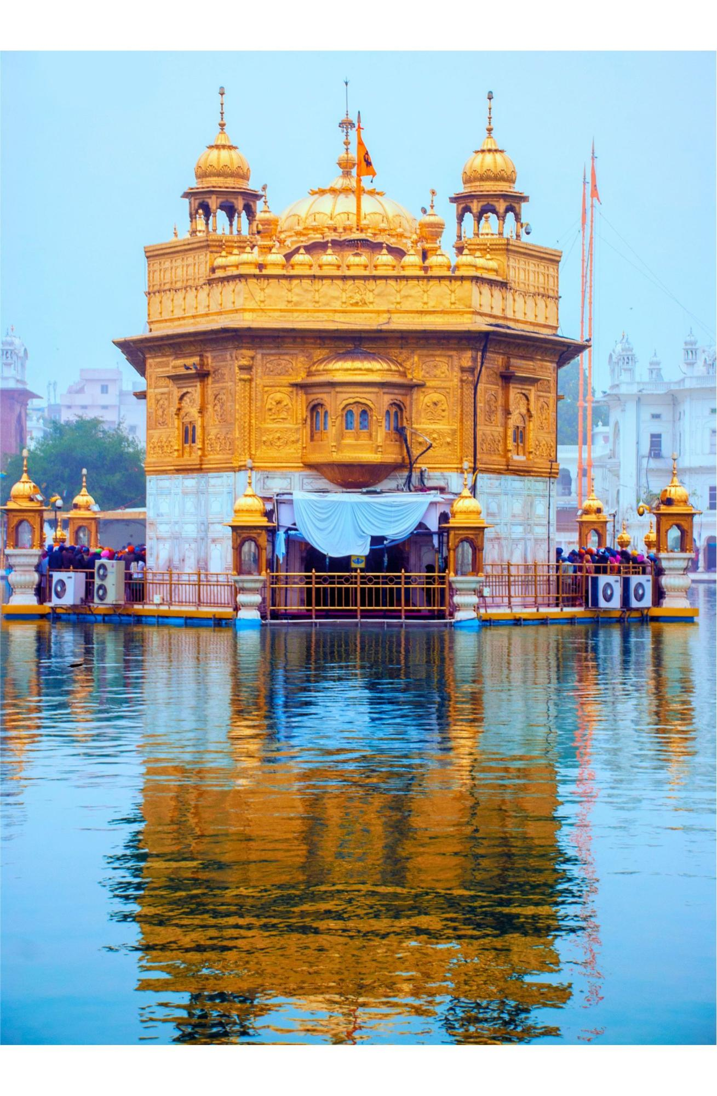

Sri Harmandir Sahib

4.9

(1.9L)

Gurdwara

The Golden Temple is a gurdwara located in the city of Amritsar, Punjab, India. It is the pre-eminent spiritual site of Sikhism.

**Ticket Fees : Free**

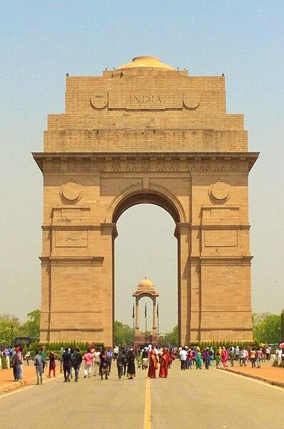

India Gate

4.6

(1.6L)

Castle

The India Gate is a war memorial located near the Kartavya path on the eastern edge of the "ceremonial axis" of New Delhi, formerly called Rajpath.

**Ticket Fees : Rs.500**